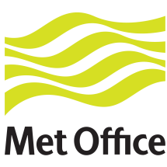

MET OFFICE SEVERE WEATHER WARNINGS

We warn the public and emergency services of severe or hazardous weather which has the potential to cause damage, widespread disruption and/or danger to life through our National Severe Weather Warning Service. This includes warnings about rain, snow, wind fog and ice.

These warnings are given a colour depending on a combination of both the likelihood of the event happening and the impact the conditions may have.
The basic messages associated with each of the colours are:

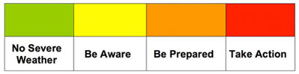

What the colours mean

- Yellow: Be aware. Severe weather is possible over the next few days and could affect you. Yellow means that you should plan ahead thinking about possible travel delays, or the disruption of your day to day activities. The Met Office is monitoring the developing weather situation and Yellow means keep an eye on the latest forecast and be aware that the weather may change or worsen, leading to disruption of your plans in the next few days.
- Amber: Be prepared. There is an increased likelihood of bad weather affecting you, which could potentially disrupt your plans and possibly cause travel delays, road and rail closures, interruption to power and the potential risk to life and property. Amber means you need to be prepared to change your plans and protect you, your family and community from the impacts of the severe weather based on the forecast from the Met Office
- Red: Take action. Extreme weather is expected. Red means you should take action now to keep yourself and others safe from the impact of the weather. Widespread damage, travel and power disruption and risk to life is likely. You must avoid dangerous areas and follow the advice of the emergency services and local authorities.

Severe weather warnings are available to you in a number of ways, meaning you can always access the latest information wherever you are. This includes on radio, TV, the Met Office website, social media, smart phone apps, RSS and via email alerts.

You can help by passing these warnings on to family and friends, or by sharing them on Facebook, Twitter and other social media with you friends and followers.

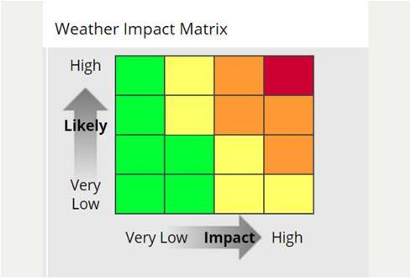
Weather Warning Matrix:

Likelihood:
Likelihood
High | - You may need to take action as we are expecting ...  - There will be ...
Medium | - We should be prepared for ...  - There is likely to be ...
Low | - Be aware of the potential/possibility ...  - There is the small chance of ...
Very Low | - Be aware that there is a very small risk of ...

Impact:
Impact
High | - TAKE precautionary ACTION and remain extra vigilant. Follow orders and any advice given by authorities under all circumstances. Ensure you access the latest weather forecast.  EXPECT significant disruption to normal daily routines.  Avoid all non-essential journeys.  If you must make a journey carry emergency food/ clothing/ blanket etc.  - Widespread flooding of property. Severe disruption to travel.  Loss of gas, electricity, water supplies. Significant disruption to communities.  Evacuation expected. Significant risk to life.  Take action to protect yourself and follow the advice of the emergency services.
Medium | - BE PREPARED. Take precautions where possible and ensure you access the latest weather forecast.  BE PREPARED for some disruption to normal daily routines.  Travel only if well prepared and BE PREPARED for longer journey times.  - Some flooding of homes, businesses and transport links possible.  Disruption to travel likely. Disruption to gas, electricity, water supplies and telecoms. Some evacuations may be required. Be prepared to protect yourself and your property.
Low | - BE AWARE and ensure you access the latest weather forecast for up to date weather information.  Expect some minor delays due to slower traffic.  Outdoor events may be disrupted or cancelled.  - Localised flooding of low lying fields, recreational land and car parks.  Flooding of a small number of homes and businesses.  Wet road surfaces and possibility of ponding water, especially in known trouble spots.  Local disruption to travel - longer journey times.  Water on roads - drive according to the conditions encountered.
Very Low | - The weather is not expected to have any noticeable impacts but there may be some minor issues e.g. when travelling some extra care may be needed on occasions and there may be some disruption to outdoor events.  - Some flooding of low lying fields, recreational land and car parks but little or no disruption to travel.  Wet road surfaces and possibility of ponding water leading to difficult driving conditions.  Take extra care when driving in affected areas.

