Investigation into a low flow or low water levels query in the Eastern Yar catchment around the Morton and Sandown Area
27/11/2015

- Query
Concern about low water levels in the Eastern Yar and deterioration in wildlife on land adjacent to the river around Morton and Sandown, around SZ 599 853.

- Response: Assessment of conditions
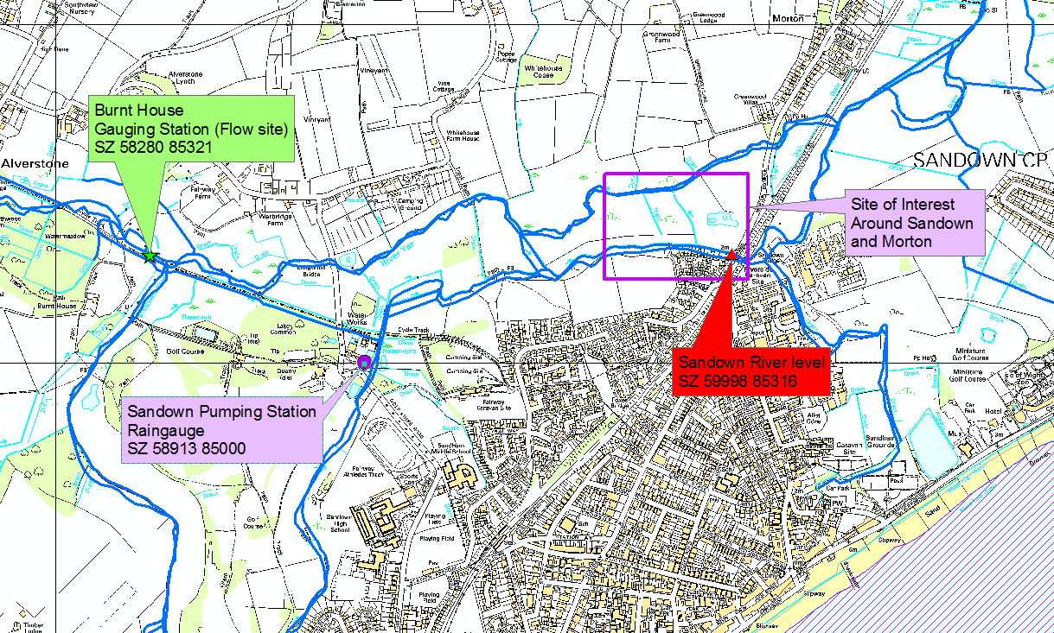
Figure 1: Site of Interest around Sandown Bridge and Morton

EA flow monitoring sites along the Eastern Yar have shown that, over the last few years, annual and summer flows have been above average. So there are plenty of water resources in the Eastern Yar catchment. This means that low flows are unlikely to be the reason for the decline in the wildlife area.

However, while there might be enough water flowing in the river, the river’s physical channel characteristics can impact on water levels, by increasing or decreasing the area of the channel. For example removing in river vegetation which “fills” the area of the channel can decrease water levels and then bankside vegetation that insects and wildlife rely on declines. Lowering water levels can also mean that water cannot spill over the bank or flow into smaller off-take channels to wet areas up. However, there is no information on whether these kinds of activities to lower water levels have been undertaken in the area. Instead, as it happens, we can actually physically see water level in the river at the Morton and Sandown area as there is an EA river level monitoring site at Sandown, under the road bridge.

The river levels at Sandown show that annual and summer levels, over the last few years, have been average or above average. Therefore, it is unlikely a change in water level in the Easter Yar channel is the source of the decline in wildlife.

So site specific conditions may be at play to explain the decline in wildlife in the area. The Morton area lays on clay geology which acts as a barrier to any underlying aquifer (groundwater). The majority of the river catchment upstream of Morton flows over an aquifer type called the Lower Greensand. This aquifer adds water the river when groundwater levels are higher than the river bed, and so the river flows all year and rarely dries up. But the lower end of the Eastern Yar including Morton does not gain any groundwater and so this area’s land relies purely on rainfall to add water to it. Therefore, the land around Morton is influenced heavily by rainfall and may dry up even when river levels and flows are fine.

To see if lack of rainfall might be the issue rainfall totals were assessed. These showed that while annual totals of the area were around average the last few years that the summer (Apr-Sep) rainfall totals in 2013, 2014 and 2015 were actually below average. So this below average summer rainfall may be the contributing factor to the “drying” up of the land around Morton.

Digging deeper into the rainfall it also shows that in most of the summer months the rain that fell over the area was the “wrong kind of rain” for helping keeping land wetted up. That is, rather than smaller regular amount of rainfall, the rainfall has been heavy one-off events. Heavy rainfall does not get a chance to be absorbed by the ground and the literally runs off the dry land and into the river in the summer, so he rain is not retained on the land, so water source on site will dry up. Once there is no t enough water on a site insects tend to leave (or die off) and once the insects are gone the birds go. So it is a very fine balance.

The Brading Marshes SSSI new management system attempts to mitigate for any drying up of that land. The Bembridge Harbour tide gates controls the water level in the Eastern Yar at the downstream end of the Marshes and holding up or releasing water. Holding water levels up means that water is allowed to flow into off-take channels on site to help move water around to keep the site wet. The site also has some groundwater input from Chalk spring along its edges, so unlike the Morton land is has an extra water contribution which is why it is mostly wet all year and the gate control is just to keep it as wet as possible. The water level control by the Bembridge Gate does not affect levels upstream at Morton, as it is too far away.

Therefore, from what evidence we have it is suggested that the decline in the wildlife around the Morton and Sandown area for the last few years is likely due the land drying up due to the lack of and pattern of summer rainfall, and due to the area being underlain by clay and so water on site is purely dependant on rainfall. However, this investigation is done as a desk study using hydrometric data and there may be other local site conditions that are not known about that could also be contributing to the issue.

Bethan Davies
Technical Specialist Hydrology
10/12/2015

- Evidence: Eastern Yar Background

3.1. Hydrology of the Eastern Yar Catchment
The Eastern Yar rises around the area Whitwell and Niton and flows in a general easterly direction before flowing through Brading Marshes to join the sea at Bembridge Harbour some 21 km from its source. The river drains a catchment area of 350 km2.

The river is fed at its headwaters by springs from the Southern Downs Chalk. Some river flow is also provided from the Lower Greensand aquifer as the river flows over it in the top half of the catchment (Figure 2). This type of geology makes the flows in the top half of the river’s catchment reasonably stable.

However, for lower half of the catchment the Eastern Yar flow largely over clay geology (Figure 2). Clay geology is impermeable and this geology means that when it rains the majority of water runs straight into the river rather into the ground to feed an aquifer as happens in the top of the catchment. So when it rains over the clay geology the river responds quickly and has what we call a “flashy” nature – that is it rises and falls quickly. So in the lower reaches of the Eastern Yar its character can show a highly seasonal nature with high winter floods but sluggish summer flows. The sluggish summer flows are due to the fact that without rain there is no gain in flows. The sluggish summer flows are also partly to do with the fact that the river valley is a flat coastal plain and therefore has very little gradient.

The Eastern Yar has two main tributaries – the Bathingbourne Stream (otherwise known as Wroxall Stream) and the Scotchells Brook. The Scotchells Brook flows are significant in comparison with the Eastern Yar flows. In fact while the Brook has a smaller catchment than the Yar at the point it joins the Yar it generates more flow because Brook’s catchment has significant groundwater ingress. After the Scotchells brook joins the Eastern Yar there is very little gain in flow to the river, unlike when it runs of the aquifer geology upstream. So the flow in the Yar at the Scotchells Brook confluence plus the Book’s flow itself the total flow seen at mouth of the river at Bembridge.

The catchment is predominantly rural, with a large cover of woodland, wetlands and agricultural land along the river valley. Agriculture is intensive in the catchment.
Figure 2: Eastern Yar catchment

2.2 Features of the Eastern Yar due to its Hydrology
There are many conservation sites associated with or located within the Eastern Yar catchment. The highest conservation designation is to the coastline around the
island which part of the South Wight Maritime Special Area of Conservation (SAC) and to Bembridge Harbour which is part of the Solent & Southampton Water Special Protection Area (SPA).

There are also several sites of special scientific interest (SSSI) along the river valley with are mainly wetland areas, such as Cridmore Bog and Braiding Marshes. Brading Marshes in particular is a feature of the clay geology and flat topography of the catchment. There are current activities in place by the EA and RSPB at to encourage the habitat for birds and to raise water levels to put the SSSI back into favourable condition. This includes using the tidal gates at Bembridge to raise water levels in the Yar to help move water onto the Brading Marshes SSSI.

Another feature is that the flow from the river at its mouth into Bembridge Harbour is controlled by tidal gates at Bembridge Harbour Wall. The gates are operated by the EA to control water levels in the Eastern Yar, in particular to help alleviate upstream flooding. The Brading Marshes SSSI directly upstream of the tide gates are used as flood storage. There is a fine balance in using the Brading Marshes as flood storage and as wetland habitat.

Agriculture is intensive in the catchment and so there are numerous agricultural water abstractions. There are also public water supply abstractions in the catchment which serve the Island population. There are two major public water supply sources located at Burnt House and Kniton. Burnt House is a surface water abstraction and Kniton is a groundwater abstraction. Water is also transferred in from the River Medina to augment (add water) to the Eastern Yar at times of low flow to help maintain the flow condition the Burnt House licence and allow this abstraction to operate as much as possible. The catchment is also heavily abstracted for agricultural spray irrigation and trickle irrigation (which is presently in the process of becoming a licensable activity). The Eastern Yar water resources assessment in respect to water uses in the catchment such as the abstractions and with the environment as a “user” show the resource are currently in balance. However, no more abstraction is now allowed to be licensed (except at high flows) in the catchment as that would tip the balance and lead to environmental damage.

Monitoring Sites on the Eastern Yar
Our Hydrometric network monitors the components of the hydrological cycle including rainfall, groundwater characteristics, as well flow characteristics of surface waters.

We have several types of hydrometric monitoring sites along the Eastern Yar including river level sites, river flow sites, groundwater monitoring sites and rainfall sites. These can be seen on Figure 1

Site of Interest around Sandown Bridge and Morton
The river network of the Eastern Yar around Morton Bridge can be seen in Figure 2.
The query is about whether flows and water levels have been impacted in recent years from human activities rather than just climate. In order to assess this, the climate element must first be eliminated.

Rainfall
River flows and groundwater levels are influenced by the amount of rain that has fallen. The nearest raingauge to the Morton area is Sandown Pumping Station manually read raingauge. However, the data at this site is patchy in recent years so the Knighton raingauge, which is only xx km away, will be used instead. Knighton data starts in 1952 so it has a long and complete record to be able to use with confidence to look at trends in rainfall. We measure rainfall in millimetre, so as to understand the depth of water falling over an area. It is an “on the spot” measurement and rainfall as we know can be significantly different from one location to another. However, that is why we have a network of raingauges and each one is give us the best estimate of the rainfall falling around the area of the gauge. Some fo this rain will run straight into rivers, some of it will be absorbed into the ground to feed and replenish our groundwater aquifers. In the Morton area the ground beneath the soil is mostly clay which acts as a barrier to water and so most of the rainfall falling over the area will “runoff” the land and make its way into the Easter Yar.

We use 30 year standard periods for our hydrometric statistics as this should give us enough of a time span to have different types of climatic conditions such as wet, dry and average years. Using 30 year periods also lets us compare any difference and trends in rainfall patterns. Since we are looking at current conditions on site then we will use the standard period of 1981-2010. The average annual total for Knighton raingauge (1981-2010) is 823mm, for “summer” (April to end of Sept) is 306 mm, and for winter (October to end of March) is 517 mm. Figure 3 shows the annual total rainfall from the last ten years compared to the annual average rainfall.

Figure 3: Knighton Average Annual Rainfall 1981-2010

It can be seen from Figure 3 that there was a pickup in rainfall in 2007 after two below average years – in fact this was during our last long term drought of winter 2004 to summer 2007 when it just started to pour again. There is then an obvious slow decline in rainfall from 2007 to 2011. In winter 2010-2011 we had another short term drought but in the winter rather than the summer (which is generally more worrying than a summer drought as we rely on winter rainfall to keep thing topped up ready for low rainfall summer months). However, rainfall has been way about average since 2011 and we are on track to being just above average for 2015.

The data shows that the last few years have shown a trend for rainfall to be over-average. However, this is based on an annual total and we know that rainfall is variable per month throughout the year and per season. Using “summer” rainfall totals in Figure 4 a slightly different picture is seen. Figure 4 shows no real trend in summer rainfall but that apart from 2012 summer rainfall has been below average since 2009. On the clay geology of the Morton area this will have an immediate effect and there would have been lower flow and water levels as a result. However, the upstream end of the Eastern Yar has a good groundwater input so this will be keeping some of the flow going during these times of low rainfall, the flow and water level data for the river will show how significant an impact this lower summer rainfall has been.
Figure 4: Knighton Summer Rainfall trend

Flows
Burnt House GS (gauging station) is the nearest flow monitoring site and is upstream of Morton Bridge. Flow is presented as a rate, usually as cubic meters per second (m³/s). Flow is calculated as area of the channel multiplied by its velocity. There are various ways to measure velocity and area. For Burnt House GS a weir has been built and the weir allows standard mathematical formulas to be used which relate depth of water behind the weir to flow. We monitor flows at Burnt House GS in 15 minute timesteps and this can be turned into daily, monthly and annual flows. The Burnt House GS flows are impacted by a large public water supply abstraction upstream.

Looking at the same 10 year period as the rainfall of 2005-2015 we can plot up the overall average daily flow for each year (annual average daily flow) against the long term average annual daily flow (1981-2010) of 0.5 m³/s.
.
The data in Figure5 does not show the same pattern as the rainfall (in Figure 3 nor 4). Although the most recent 4 years’ flows are obviously higher than the previous years which does matches the overall trend for the rainfall. 2004 and 2011 are also the lowest years as in the rainfall. Summer flows at Burnt House show the same pattern as the annual so there is no variation like with the rainfall.

The main reason for the flow being “held up” while the rainfall is low is due to the input (additional water) to the river from the groundwater further up in the catchment. Therefore, it doesn’t appear that flows have been particularly low over the last few years compared with the mid 2000’s. However, flow is a rate and while there may be plenty of water in the river it may be that physically water levels have changed at the Morton site due to modification of the channel or changes in use of structures downstream. So then next section looks into water level changes.

Figure 5: Burnt House GS average annual flows

Water level (stage)
The nearest river level monitoring site to the Morton area is Sandown River Level. This site is just downstream of the Morton area of interest (Figure 2). Water level (also referred to as stage when it is related to a local datum) is usually measured in meters or in meters Above Ordnance Datum (mAOD), the datum being mean sea level. We use “mAOD” to be able to relate the water levels of all the hydrometric monitoring network sites to each.

The Sandown record only starts in 2003 and so there is not enough data to use a 30 year standard period of record like with the rainfall and flow sites. So the long term annual average water level at Sandown River Level site is estimated to be 0.46 mAOD for period 2004-2014.

The annual average water levels for the last 10 years were plotted and the pattern matches the annual rainfall almost identically, except the last couple of year where water levels were average or just over while rainfall was below average. The summer water levels were also plotted, as we did with the rainfall, and can be seen in Figure 6. The levels pattern almost matches the summer rainfall pattern except that the water levels over the last 3 years have been over average rather than below as the rainfall shows. Therefore, it appears that water levels have been normal for the last few years and so it is unlikely that they are the reason that the wildlife area has appeared to suffer.

Figure 6: Sandown Summer River Levels and Knighton summer rainfall

